**Budget Planner Website**

**Projection Description:**

As a developer, write a program using JavaScript to decide the budget of a specific team.

**Background of the problem statement:**

As a developer, you are assigned to a project. You need to develop a website where program managers of a specific team will add details of professional deals they want to have with vendors. The finance team will check expenses of those teams and will decide their annual budget.

**The website needs to have the following features:**

**You must use the following:**

● Visual Studio Code: An IDE to code for the application  
● JavaScript: A programming language  
● Git: To connect and push files from the local system to GitHub  
● GitHub: To store the application code and track its versions  
● JavaScript concepts: Functions, prototypes, primitives, objects, IIFEs, promises, async, and webpack

**Following requirements should be met:**

● Versions of the code should be tracked on GitHub repositories   
● Team Budget Planner should work properly

**Project Users Stories**

As a full stack developer, I want to develop restaurant website,

* As a user, I want to have a website to plan my budget.
* As a user, I want a form to enter budget and expense list.
* As a user, I want to see the balance with the above entered details.
* As a developer, I want to build responsive website for budget planner.
* As a developer, I want to use bootstrap components such as navbar, a CTA button, a grid, and a footer component to build website.
* As a developer, I want to develop a form to enter budget and expenses.
* As a developer, I want to display the expenses list and remaining balance.

**Sprint 1 (Week 1)**

* As a developer, I want to build responsive website for budget planner.
* As a developer, I want to use bootstrap components such as navbar, a CTA button, a grid, and a footer component to build website.
* As a developer, I want to develop a form to enter budget and expenses.
* As a developer, I want to display the expenses list and remaining balance.
* Testing the Java program with different kinds of User input.
* Initializing git repository to track changes as development progresses.
* Pushing code to GitHub.
* Creating this specification document with application details, appearance, and user interactions.

## **Concepts used in project**

* + - HTML, CSS, JavaScript,
    - Bootstrap header, nav bar, forms, section, footer, table and grid components.

**Architecture diagram / flow chart:**

**Start**

**Create a website for budget planning. Create forms to enter the budget and expenses.**

**Upon budget form submit action, budget amount gets displayed on the screen.**

**Upon expense form submit action, expense list gets displayed on the screen in a table format. Total expense and balance amount are calculated and displayed.**

**End**

**Screenshots,**

* Budget Planner website and different navigation section screenshots,

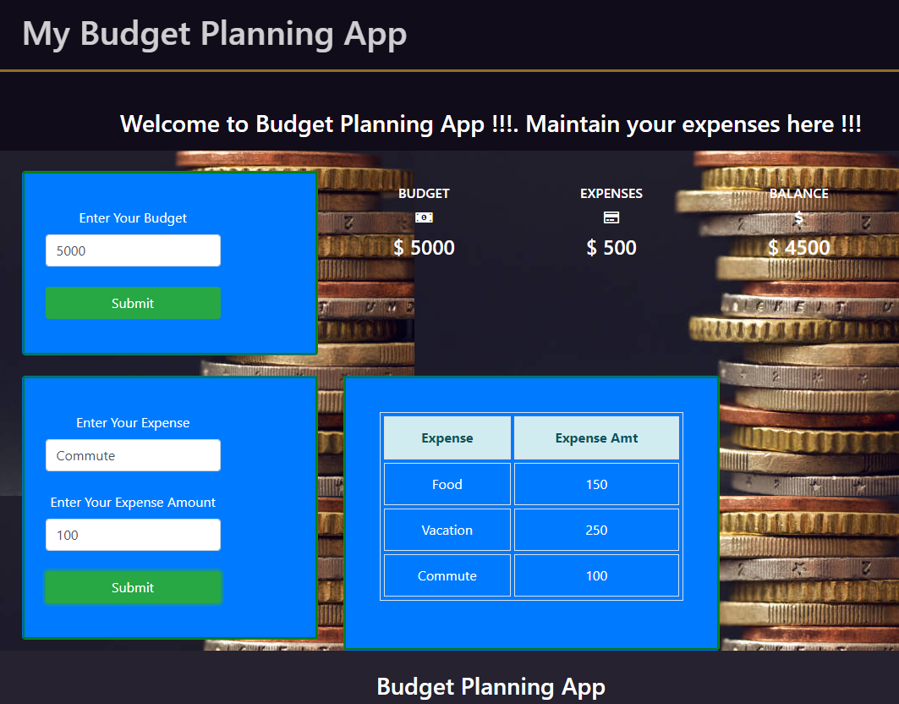



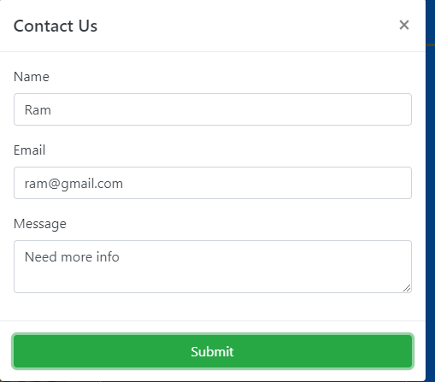

## **Pushing the code to GitHub repository**

* Open your command prompt and navigate to the folder where you have created your files.

**cd <folder path>**

* Initialize repository using the following command:

**git init**

* Add all the files to your git repository using the following command:

**git add .**

* Commit the changes using the following command:

**git commit -m <commit message>**

* Push the files to the folder you initially created using the following command:

**git push -u origin main**

**Source code for the project available under below repository,**

# [S-KAVITHA](https://github.com/S-KAVITHA)/[Phase4-Practice-Projects](https://github.com/S-KAVITHA/Phase4-Practice-Projects) /**BudgetPlanner**/